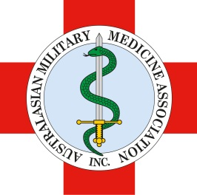
AMMA NEW ZEALAND REGIONAL SYMPOSIUM
SATURDAY 21 MARCH 2015
TRENTHAM MILITARY CAMP, WELLINGTON, NEW ZEALAND
FACILITATED BY
DR ANDREW ROBERTSON (RAN) AND DR DARRYL TONG (RNZAMC)

Draft Program
Times | Morning Session - Ballistics – Dr Andrew Robertson
0900-0905 | Welcome
0905-0930 | Introduction
0930-1000 | Penetrating Injuries
1000-1015 | Morning Refreshments
1015-1045 | Blast Injuries
1045-1115 | Case Study - Madrid
1115-1145 | Burns
1145-1200 | Health System Activation, Response and Escalation
1200-1230 | Scenario – Media and Psychological Response
1230-1245 | Questions
1245-1330 | Lunch
1330-1700 | Afternoon Session - Combat Facial Trauma – Dr Darryl Tong
1330-1400 | Background history
1430-1500 | Epidemiology
1500-1515 | Afternoon Refreshments
1515-1600 | Initial Assessment
1600-1630 | DCS
1630-1700 | Panel Discussion
1700 | Close

